MiSACWIS Project

CM02 – View Case Overview Screen Specification

Version 1.10

October 1, 2012

Prepared for:


120 N. Washington Square
SACWIS Project, 3rd Floor
Lansing, MI 48933

Prepared by:

Revision Log
Version | Date | A/D/C (Add, Delete, Change) | Author | Document Section # | Description
0.1 | 08/11/2011 | A | N Page |  | Initial version
0.2 | 08/15/2011 | A | S Kulkarni | 3.1 | Added To Be Screens
0.3 | 08/18/2011 | C | S Kulkarni  N Page | 3.1  2.2, 2.11, 3.1.2, 3.1.5, 3.3.4 | Modified To Be Screens  Updates based on DD Session discussion
0.4 | 08/18/2011 | C | N Page | 3.1.5 | Assignment History sort
0.5 | 08/19/2011 | C | N Page | 3.2.3, 3.1.3 | Updated based on Roundtable discussion  Modified To Be Screens
0.6 | 08/23/2011 | C | N Page | 3.1.5  3.1.3 | Removed business rule as it belongs to a diff Use Case.  Modified To Be Screen  Screen Fields
0.7 | 08/25/2011 | C | N Page | 3.1.3, 3.2.3 | Screen Field characteristics updated
1.0 | 08/25/2011 | C | N Page |  | Approved
1.1 | 08/31/2011 | A/D/C | M. Stubbs | Field Grids | Quality Assurance Review:  Updated To Be Class Attributes To Be Type, To Be Calculations and UI Validations in Section 3.1.3 and 3.2.3.  No functionality impact. Updated information highlighted in yellow.
1.2 | 10/26/2011 | C | N Page | 1,  2.2 moved to 3.5,  2.3  Note in 3.1.5 moved to 2.11  3.1.6 | Change Control # 1512  Quality Assurance Review: No functionality impact.
1.3 | 11/11/2011 | C | N Page | 1 | Updated Purpose
1.4 | 11/16/2011 | C | S Kulkarni | 3.1.3 | Change Control # 1512  Quality Assurance Review: No functionality impact. Updated field grids
1.5 | 11/28/2011 | C | N Page | 3.1.4  3.1.5 | Change Control # 2012  Quality Assurance Review. No functionality impact.
1.6 | 12/29/2011 | C | N Page |  | Approved  All revisions accepted
1.7 | 01/16/2012 | C | N Page | 2.2, 2.3 | Change Control # 2808  Security grid
1.8 | 03/19/2012 | C | N Page | 3.1.5 | Change Control # 5750  Change Control # 6307
1.9 | 09/24/2012 | C | N Page | 3.1.5 | Change Control #15464  BR 3.1.5.2 changed from ‘Keep’ to ‘Delete’.  BR 3.1.5.7 (‘Add’) removedl
1.10 | 10/01/2012 | C | N Page | 3.1.2, 3.1.3, 3.1.5 | Change Control # 19217

Table of Contents
1 Introduction 7
1.1 Purpose 7
1.2 Scope 7
2 Use Case Details 8
2.1 Action Buttons/Hyperlinks 8
2.2 Business Rules 8
2.3 Security Requirements 8
2.4 Screen Navigation 9
2.5 Tab Order 9
2.6 Pre-Conditions 9
2.7 Ticklers 10
2.8 Notifications 10
2.9 Calendar 11
2.10 Reports 11
2.11 Notes and Assumptions 11
3 Screen Details 12
3.1 Case Overview 12
3.1.1 As Is – View Case Overview Screen 12
3.1.2 To Be – View Case Overview Screen 13
3.1.3 Screen Fields 14
3.1.4 Action Buttons/Hyperlinks 21
3.1.5 Business Rules 22
3.1.6 Screen Navigation 24
3.1.7 Pre-Conditions 24
3.1.8 Reference Values 24
3.2 Case Status History 25
3.2.1 As Is – Case Status History Screen 25
3.2.2 To Be - Case Status History Screen 26
3.2.3 Screen Fields 27
3.2.4 Action Buttons/Hyperlinks 29
3.2.5 Business Rules 30
3.2.6 Screen Navigation 30
3.2.7 Pre-Conditions 30
3.2.8 Reference Values 30

List of Figures
Figure 1 – As Is - Case Overview 12
Figure 2 – To Be - Case Overview 13
Figure 3 – As Is - Case Status History 25
Figure 4 –To Be - Case Status History 26

Introduction

Purpose
The CM02 - View Case Overview use case provides the user with a high-level overview of case demographics. The Case Overview page is typically the landing page for a worker when navigating to a case to either record or view case information representing the agency’s interaction with clients. Additionally, the Case Overview page provides a static display of the following case specific details:
- Case ID
- Case Name
- Case Address
- Case Status
- Organization
- Safety Hazards
- Case Assignment information
- Ticklers
Additionally, the Case Overview page provides authorized users access to other case information including information about case members, relationship, associated person, households, linked and associated cases and program type history.

Scope
The View Case Overview Use Case demonstrates a Worker’s ability to display a high-level overview of the current status of a case in MiSACWIS. The Case Overview page provides the user access to historical information such as case status, linked cases and assignment history. In addition, this Use Case allows the user to view case detail information.

Use Case Details

Action Buttons/Hyperlinks
Status (Keep/Add/  Modify/Delete) | Label | Type | On Click Action/Navigation
Keep | Help | Hyperlink | Screen level Help appears in a separate browser window.

Business Rules
No. | Status (Keep/Add/Modify/Delete) | Business Rule Description | Modified Business Rule Description | Execution Event (field tab out/save etc) | Error Msg Code  To be completed by Development Team
 | Add | All DHS Workers and Assigned non-DHS workers can read Case Overview information.

Security Requirements
No. | Status (Keep/Add/  Modify/Delete) | Security Requirement
1 | Keep | Create  N/A
2 | Keep | Read  Worker
3 | Keep | Update  N/A
4 | Keep | Delete  N/A

Screen Navigation
No. | Status (Keep/Add/  Modify/Delete) | To Screen Navigation Path
1 | Keep | Navigate From Case Search result page
2 | Keep | Navigate from Workload page

Tab Order
No. | Status (Keep/Add/  Modify/Delete) | Screen name
1 | N/A

Pre-Conditions
No. | Status (Keep/Add/Modify/Delete) | Pre-Condition
1 | Keep | Case must be in MiSACWIS

Ticklers
Status (Keep/Add/Modify/Delete) | Tickler Name | Trigger Action | Tickler Generation Business Rule & Description | Tickler Removal Business Rule | Tickler Text
Status (Keep/Add/Modify/Delete) | Tickler Role
 | N/A

Notifications
Status (Keep/Add/Modify/Delete) | Notification Name | Trigger Action | Message Business Rule & Description | Message Text
Status (Keep/Add/Modify/Delete) | Notification Role | Trigger Action | Message Business Rule & Description | Message Text
 | N/A

Calendar
Status (Keep/Add/Modify/Delete) | Calendar Name | Trigger Action | Calendar Event Generation Business Rule & Description | Calendar Event Date and Time Business Rule | Calendar Event Text
Status (Keep/Add/Modify/Delete) | Calendar Role
 | N/A

Reports

Notes and Assumptions
Although the Assignment Information grid appears on a CM02 screen and therefore the fields are in the Screen Fields grid, defining the sort order of the rows in this grid is handled in CF11 – View History of Workers Assigned to a Work Item.

Screen Details

Case Overview

As Is – View Case Overview Screen
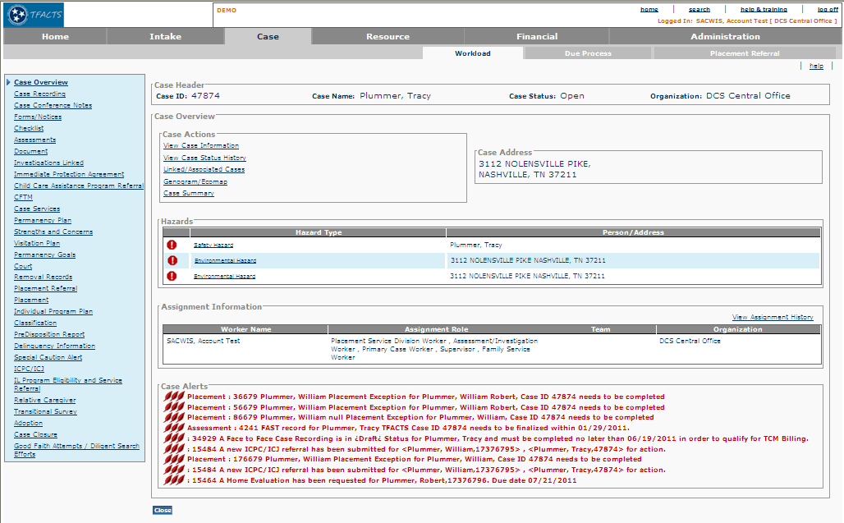
Figure 1 – As Is - Case Overview

To Be – View Case Overview Screen

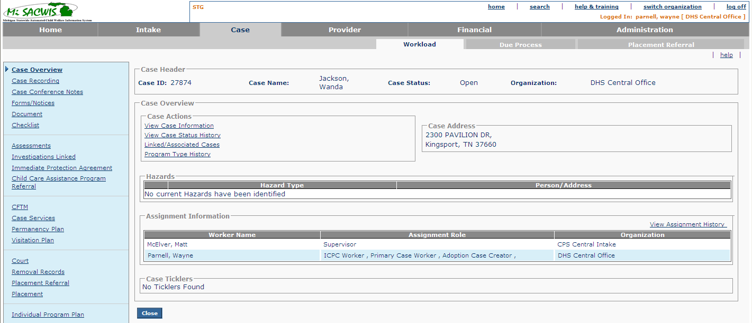
Figure 2 – To Be - Case Overview

Screen Fields
Status (Keep/  Add/  Modify/  Delete) | As Is Class.Attribute Name | To Be Class.Attribute Name | As Is Display Name | To Be Display Name | To Be Type | To Be Align | To Be Size | To Be Read Only | To Be Calculation | To Be Edit Mask | To Be UI Validation
Keep | N/A | N/A | Case Header | Case Header | Section Header | L | N/A | T
Keep | CaseBase.caseID | CaseBase.caseID | Case ID | Case ID | Display Text | L | 20 | T
Keep | CaseBase.caseLastName + CaseBase.CaseSuffixNameCode  +CaseBase.caseFirstName + CaseBase.caseMiddleName | CaseBase.caseLastName + CaseBase.CaseSuffixNameCode  +CaseBase.caseFirstName + CaseBase.caseMiddleName | Case Name | Case Name | Display Text | C | 100 | T |  | Last Name, First Name Middle Name
Keep | caseStatus.caseStatusCode | caseStatus.caseStatusCode | Case Status | Case Status | Display text | L | 30 | T | System derived from CaseStatus where caseStatus.endEffDate is null  Use short desc from Ref Data where domain code = ‘CaseStatus’
Keep | Agency.agencyName | Agency.agencyName | Organization | Organization | Dsiplay text | L | 100 | T | System derived from CaseAgencyLink.caseAgencyLinkId where end date is null
Keep | N/A | N/A | Case Overview | Case Overview | Section Header | L | N/A | T
Keep | N/A | N/A | Case Actions | Case Actions | Section Header | L | N/A | T
Keep | N/A | N/A | View Case Information | View Case Information | Hyperlink | L | N/A | T
Keep | N/A | N/A | View Case Status History | View Case Status History | Hyperlink | L | N/A | T
Keep | N/A | N/A | Linked/Associated Cases | Linked/Associated Cases | Hyperlink | L | N/A | T
Modify | N/A | N/A | Case Summary | Program Type History | Hyperlink | L | N/A | T
Delete | N/A | N/A | Genogram/Ecomap | Genogram/Ecomap | Hyperlink |  | N/A | T
Modify | Address.streetNbr + Address.preDirectionalCode + Address.streetName + Address.streetSuffixCode + Address.postDirectionalCode + Address.UnitNameCode + Address.UnitNumber + Address.CityName + Address.stateCode + Address.zip5Code + Address.zip4Code | Address.streetNbr + Address.preDirectionalCode + Address.streetName + Address.streetSuffixCode + Address.postDirectionalCode + Address.UnitNameCode + Address.UnitNumber + Address.CityName + Address.stateCode + Address.zip5Code + Address.zip4Code +  Address.tribalReservationFlag | Case Address | Case Address | Display Text | L | N/A | T | Use primary address information associate to Case Reference Person | Use Standard Address Display Text Format
Keep | N/A | N/A | Hazards | Hazards | Section Header | L | N/A | T
Keep | N/A | N/A | See graphic on screen shot (!) | See graphic on screen shot (!) | Graphic/Grid column |  | N/A | T | See BR 2.2 for display information
Keep | Person.safetyHazardFlg , Person.environmentalHazardFlag, Person.mentalHealthHazardFlag, Person.drugActivityHazardFlag, Person.contagiousDiseaseHazardFlag, Person.domesticViolenceHazardFlag, Person.gangActivityHazardFlag, Person.priorWorkerThreatsHazardFlag, Person.gangActivityHazardFlag, Person.priorWorkerThreatsHazardsFlag, Person.violentCrimeConvictionFlag, Person.sexualPredatorFlag, Person.explosiveBehaviorFlag, Person.protectiveServiceAlertFlag | Person.safetyHazardFlg , Person.environmentalHazardFlag, Person.mentalHealthHazardFlag, Person.drugActivityHazardFlag, Person.contagiousDiseaseHazardFlag, Person.domesticViolenceHazardFlag, Person.gangActivityHazardFlag, Person.priorWorkerThreatsHazardFlag, Person.gangActivityHazardFlag, Person.priorWorkerThreatsHazardsFlag, Person.violentCrimeConvictionFlag, Person.sexualPredatorFlag, Person.explosiveBehaviorFlag, Person.protectiveServiceAlertFlag | Hazard Type | Hazard Type | Hyperlink | L | N/A | T
Keep | Person.LastName + Person.suffixNameCode + Person.FirstName + Person.middleName  Or  Address.streetNbr + Address.preDirectionalCode + Address.streetName + Address.streetSuffixCode + Address.postDirectionalCode + Address.UnitNameCode + Address.UnitNumber + Address.CityName + Address.stateCode + Address.zip5Code + Address.zip4Code | Person.LastName + Person.suffixNameCode + Person.FirstName + Person.middleName  Or  Address.streetNbr + Address.preDirectionalCode + Address.streetName + Address.streetSuffixCode + Address.postDirectionalCode + Address.UnitNameCode + Address.UnitNumber + Address.CityName + Address.stateCode + Address.zip5Code + Address.zip4Code +  Address.tribalReservationFlag | Person/Address | Person/Address | Display Text | L | N/A | T | For address, use the CRP Primary Address information | Use Standard Person Name Display Text Format or Address Display Text Format
Keep | N/A | N/A | Assignment Information | Assignment Information | Label | L | N/A | T
Keep | N/A | N/A | View Assignment History | View Assignment History | Hyperlink | R | N/A | T
Keep | Person.LastName + Person.suffixNameCode + Person.FirstName + Person.middleName | Person.LastName + Person.suffixNameCode + Person.FirstName + Person.middleName | Worker Name | Worker Name | Display Text | L | N/A | T | Derived from WorkAssignment.employeeId  and SecurityUser.personID
Keep | role.roleName | role.roleName | Assignment Role | Assignment Role | Display Text | L | N/A | T | Derived from WorkAssignmentRole.roleId when end date is null
Keep | Agency.agencyName | Agency.agencyName | Organization | Organization | Display Text | L | N/A | T | Use employing agency of worker
Modify | Tickler.messageText | Tickler.messageText | Case Alerts | Case Ticklers | Section header | L | N/A | T | Use tickler message attributes

Action Buttons/Hyperlinks
Status (Keep/Add/Modify/Delete) | Label | Type | On Click Action/Navigation
Keep | View Case Information | Hyperlink | Executes CM03-S01
Keep | View Case Status History | Hyperlink | Executes CM02-S02
Keep | Linked/ Associated Cases | Hyperlink | Executes CM02-S03
Modify | New: Program Type History  (Old: Case Summary) | Hyperlink | Executes CM02a-View Case/Program Type
Keep | Hazard Type | Hyperlink | Executes PM01 for Person level Safety Hazard  Executes PM01c for Address level Safety Hazard
Keep | View Assignment History | Hyperlink | Executes CF11 – View History of Workers Assigned to a Work-Item (UC610)
Keep | Close | Button | Worker is returned to CM02-S01

Business Rules

No. | Status (Keep/Add/  Modify/Delete) | Business Rule Description | Modified Business Rule | Execution Event (field tab out/save etc) | Error Msg Code  To be completed by Development Team
1 | Modify | The System should display all active alerts associated to the Case on the Case Overview page | The System should display all active Ticklers associated to the Case on the Case Overview page | On refresh or screen load
2 | Delete | The most recent active hazard will display on top. |  | On Refresh or screen load
3 | Keep | The System should display all workers who are currently (non-end dated) assigned to the Case Record on the Case Overview page.  The System should display the Worker Assignment in descending order of effective date. |  | On Refresh or Screen Load
4 | Keep | Hazard Type related to a person shall Hyperlink to PM01.  If it is a Hazard Type related to an address the hyperlink shall go to PM01c |  | On Refresh or Screen Load
5 | Delete | Display “IPA Individual Identified In Case” when the safety plan (IV23 Record IPA) has reached a "Effective Finalized Status" |  | On Refresh or Screen Load
6 | Modify | Left navigation pane hyperlinks include:  ICPC/ICJ | Left navigation pane hyperlinks include:  ICPC/ICJ/ICAMA | On Refresh or Screen Load

Screen Navigation
No. | Status (Keep/Add/  Modify/Delete) | To Screen Navigation Path
1 | Keep | Navigate from Case Search result page
2 | Keep | Navigate from Workload page
3 | Keep | Navigate from Alert on Home page

Pre-Conditions
No. | Status (Keep/Add/  Modify/Delete) | Pre-Condition
1 | Keep | Case must be in MiSACWIS

Reference Values
No. | Status (Keep/Add/  Modify/Delete) | To Be Class Attribute | Domain Code | Short Desc | Ref Data Code
1 | N/A

Case Status History

As Is – Case Status History Screen
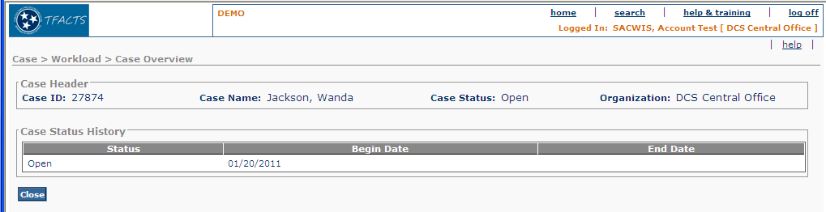

Figure 3 – As Is - Case Status History

To Be - Case Status History Screen

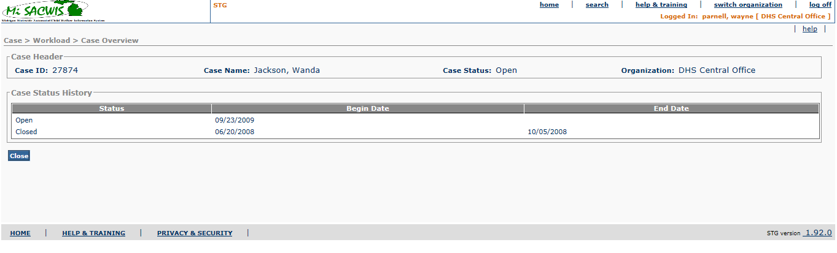

Figure 4 –To Be - Case Status History

Screen Fields
Status (Keep /Add/  Modify/  Delete) | As Is Class.Attribute Name | To Be Class.Attribute Name | As Is Display Name | To Be Display Name | To Be Type | To Be Align | To Be Size | To Be Read Only | To Be Calculation | To Be Edit Mask | To Be UI Validation
Keep | N/A | N/A | Case Header | Case Header | Section Header | L | N/A | T
Keep | CaseBase.caseID | CaseBase.caseID | Case ID | Case ID | Display Text | L | 20 | T
Keep | CaseBase.caseLastName + CaseBase.CaseSuffixNameCode  +CaseBase.caseFirstName + CaseBase.caseMiddleName | CaseBase.caseLastName + CaseBase.CaseSuffixNameCode  +CaseBase.caseFirstName + CaseBase.caseMiddleName | Case Name | Case Name | Display Text | C | 100 | T |  | Last Name, First Name Middle Name
Keep | caseStatus.caseStatusCode | caseStatus.caseStatusCode | Case Status | Case Status | Text Field | C | 30 | T | System derived from CaseStatus where caseStatus.endEffDate is null  Use short desc from Ref Data where domain code = ‘CaseStatus’
Keep | Agency.agencyName | Agency.agencyName | Organization | Organization | Text Field | R | 100 | T | System derived from CaseAgencyLink.caseAgencyLinkId where end date is null
Keep |  |  | Case Status History | Case Status History | Section Header | L | N/A | T
Keep | CaseStatus.caseStatusCode | CaseStatus.caseStatusCode | Status | Status | Display Text | L | 30 | T
Keep | CaseStatus.beginEffDate | CaseStatus.beginEffDate | Begin Date | Begin Date | Display Text | L | 10 | T |  | MM/DD/YYYY
Keep | CaseStatus.endEffDate | CaseStatus.endEffDate | End Date | End Date | Display Text | L | 10 | T |  | MM/DD/YYYY

Action Buttons/Hyperlinks
Status (Keep/Add/  Modify/Delete) | Label | Type | On Click Action/Navigation
Keep | Close | Button | Button closes page and returns user to Case Overview Page CM02-S01

Business Rules
No. | Status (Keep/Add/  Modify/Delete) | Business Rule Description | Execution Event (field tab out/save etc) | Error Msg Code  To be completed by Development Team
1 | Keep | The Case Status History will display all case records in reverse chronological order based on begin date. | On Screen load or refresh | 1

Screen Navigation
No. | Status (Keep/Add/  Modify/Delete) | To Screen Navigation Path
1 | Keep | From the “View Case Status History” hyperlink on CM02-S01

Pre-Conditions
No. | Status (Keep/Add/  Modify/Delete) | Pre-Condition
1 | Keep | Case must be in MiSACWIS

Reference Values
No. | Status (Keep/Add/  Modify/Delete) | To Be Class Attribute | Domain Code | Short Desc | Ref Data Code
1 | N/A

